**Background**

In preparation for the San Francisco Urban Forest Plan (2013), the Planning Department performed an Urban Tree Canopy (UTC) Analysis using aerial imagery and additional data sets to determine a canopy estimate for the City & County of San Francisco. **This analysis estimated San Francisco’s tree canopy at 13.7%.** This number supersedes a 2007 canopy estimate of 11.9% (USDA Forest Service, 2007). Given the differing methodologies used to arrive at these two numbers it is difficult to draw conclusions regarding urban forest growth or decline based on a comparison[1]. The current analysis establishes a baseline and methodology from which future canopy analyses can be conducted and compared over subsequent years to track San Francisco’s urban forest growth or decline over time.

**Methodology**

The methodology used in this analysis was developed based on similar studies in other cities and the availability of relevant data within San Francisco. The process is outlined and described below.

***Step 1: Distinguish different types of vegetation***

Tree canopy was selected from an aerial photo by translating the image into vegetation layers using three major data sources. Multispectral Digital Orthophoto Quarter Quads (DOQQs) or aerial photos that were flown in June of 2010 (selected to match available LiDAR data) were obtained from the U.S. Department of Agriculture’s Aerial Photography Field Office through their National Agriculture Imagery Program (NAIP). These one meter resolution orthophotos were combined with a commercial Light Detection and Ranging (LiDAR) dataset a height above ground, ten foot resolution raster purchased from Pictometry International Corp and flown in June of 2010. Additionally, building footprint data derived from the Pictometry data above were also used to create three vegetation layers – 1.)trees, 2.) intermediate vegetation and 3.) grass.

The process was as follows.

***Step 2: Create Vegetation Layers (Grass, Intermediate, Trees)***

The 2010 six inch LiDAR surface was reclassified according to height above ground using the Spatial Analysis extension of ArcMap 10.0. The data were divided into three classes according to height above ground.: 1) below one foot, 2) from one foot to eight feet, and 3) over eight feet. The following classes were created to account for all imagery in the photo based on height:

* + Class 1: < 1’ (Grass, pavement, soil, open water)
  + Class 2: 1’ – 8’ (Transitional layer, shrubs, cars,)
  + Class 3: > 8’ (Trees, buildings)

This data set includes everything in the city, so all things were classified. For example, along with trees, bushes and grass, buildings (Class 3), cars (Class 2) and sidewalks (Class 3) were also included. This raster was subsequently converted into three multipart polygon shapefiles representing the three classes. A vegetation layer was created next.

**Identifying Vegetation Layers**

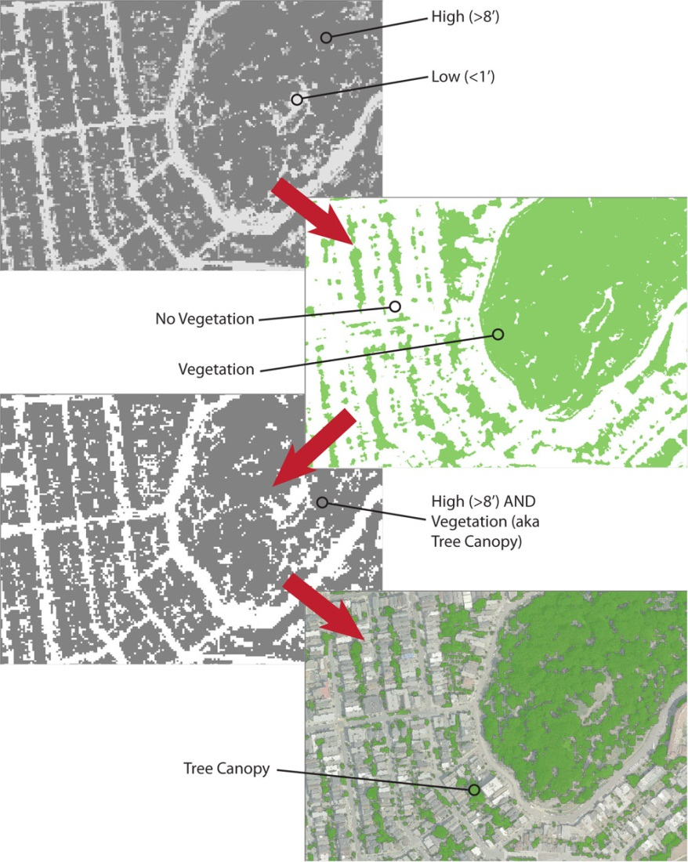

Vegetation layers were selected by combining infrared orthophotos with LiDAR height above ground data to identify and select tree canopy.

select tree canopy.

Using the DOQQs, a Normalized Difference Vegetation Index (NVDI) was created. Using the Map Algebra calculator in the Spatial Analysis extension, the following equation was performed on Band-1 (red) and Band-4 (infrared).

The NVDI calculation results in a value from -1 to 1, with a value of >0.2 mainly representing vegetation. The resulting raster was re-classified with 1 representing “no vegetation” and 2 representing “vegetation”. This re-classified raster was then turned into a vegetation polygon shapefile, and intersected with the Class 1, Class 2, and Class 3 to create polygon shapefiles for “Trees,” “Intermediate,” and “Grass”. Other datasets (blocks, lots, building footprints, streets, sidewalks, water, etc.) were used along with an eyeball analysis to separate discrete layers. The vegetation polygon shapefile was then combined with existing datasets, including streets, blocks, building footprints, and water layers to create discrete landscape layers.

***Step 3: Calculate Citywide Tree Canopy***

The “tree” polygon vegetation layer created in Step 2 was utilized to derive a percentage of the San Francisco covered by the canopy of trees (leaves, stems, branches). Tree canopy was calculated by dividing the total area of the tree layer by the total area of the city. The calculated is shown below.

***Step 4: Calculate Tree Canopy by Neighborhood***

Tree canopy coverage for individual neighborhoods was determined by dividing total tree canopy by standard Planning Department neighborhood boundaries to arrive at percentage canopy per neighborhood (see map 2).

**Notes on the Analysis & Considerations for Future Analyses**

San Francisco’s urban tree canopy should continue to be monitored at regular intervals (e.g. every five years) utilizing similar methods to the one described here[2]. These analyses will be useful to forest managers, planners and community groups in assessing the City’s progress on meeting its urban forestry goals, effectiveness of management programs and identifying areas for urban forest growth.

**MAPS**

**Map 1: Digitized San Francisco Tree Canopy**

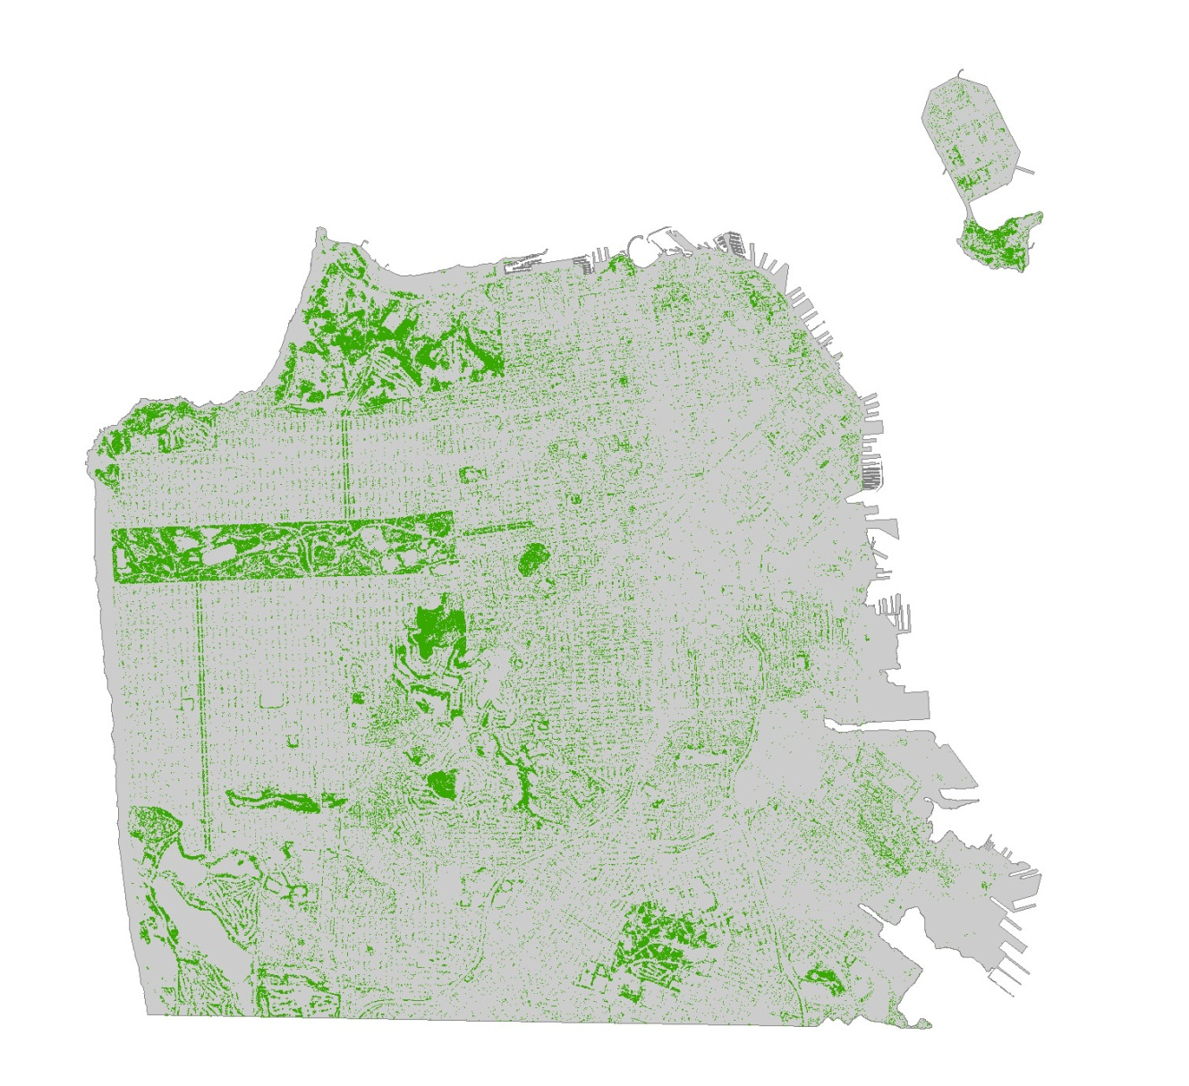

Map by Michael Webster, SF Planning Dept. (2012)

**Map 2: San Francisco Tree Canopy by Neighborhood**

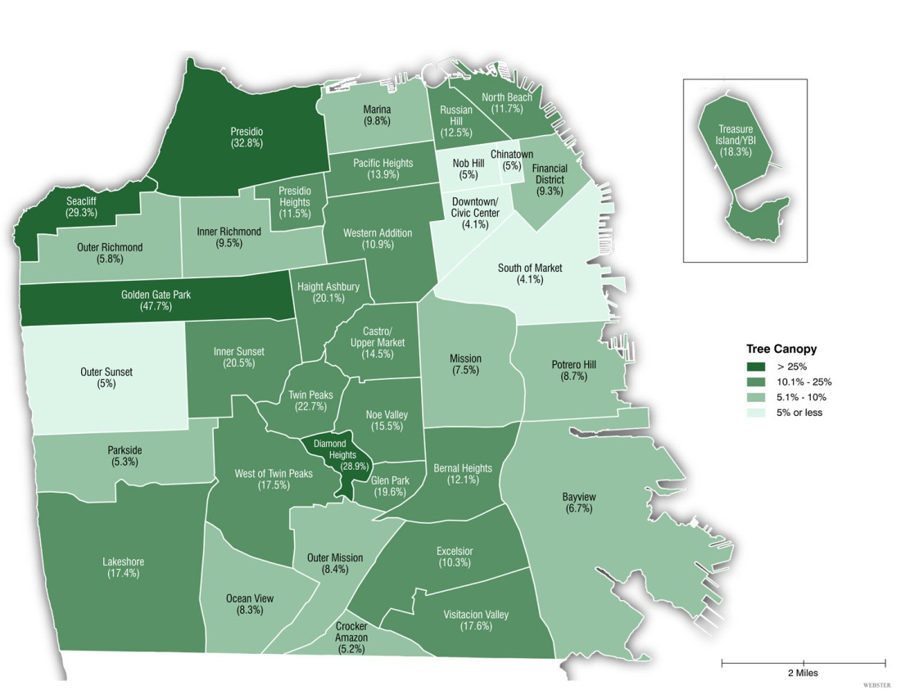

Map by Michael Webster, SF Planning Dept. (2012)

1. The United States Department of Agriculture, Forest Service’s *Assessing Urban Forest Effects and Values: San Francisco’s Urban Forest* (2007) derived an estimated citywide canopy percentage from a random selection of 200 field plots within the city that were then used to extrapolate a citywide canopy cover estimate. This method differs from the more comprehensive citywide analysis performed by the Planning Department (2013). For this reason the two estimates are difficult to compare or draw conclusions from given their different methodologies.
2. Considerations must be made regarding the availability of useful and timely data. Because of limited funding for this analysis, low-cost multispectral imagery from the NAIP program was used in conjunction with LiDAR data purchased under current City contracts and licensing with Pictometry Corp. There is no guarantee that NAIP will have 2015 imagery available or that the City will have purchased the required LiDAR data needed to perform this analysis exactly the same as described here in the future. Similar datasets, certainly, could be obtained however, resulting in increased costs for a future analysis.